Huawei VRP



Huawei Technologies Co., Ltd.

|  |
| --- |
| **Copyright © Huawei Technologies Co., Ltd. 2020. All rights reserved.**  No part of this document may be reproduced or transmitted in any form or by any means without prior written consent of Huawei Technologies Co., Ltd.  **Trademarks and Permissions**  HW_POS_RBG_Vertical-150ppi.png and other Huawei trademarks are trademarks of Huawei Technologies Co., Ltd.  All other trademarks and trade names mentioned in this document are the property of their respective holders.  **Notice**  The purchased products, services and features are stipulated by the contract made between Huawei and the customer. All or part of the products, services and features described in this document may not be within the purchase scope or the usage scope. Unless otherwise specified in the contract, all statements, information, and recommendations in this document are provided "AS IS" without warranties, guarantees or representations of any kind, either express or implied.  The information in this document is subject to change without notice. Every effort has been made in the preparation of this document to ensure accuracy of the contents, but all statements, information, and recommendations in this document do not constitute a warranty of any kind, express or implied. |

|  |  |
| --- | --- |
| Huawei Technologies Co., Ltd. | |
| Address: | Huawei Industrial Base  Bantian, Longgang  Shenzhen 518129  People's Republic of China |
| Website: | <https://e.huawei.com/> |
|  |  |

**Huawei Certification System**

Huawei Certification follows the "platform + ecosystem" development strategy, which is a new collaborative architecture of ICT infrastructure based on "Cloud-Pipe-Terminal". Huawei has set up a complete certification system consisting of three categories: ICT infrastructure certification, platform and service certification, and ICT vertical certification. It is the only certification system that covers all ICT technical fields in the industry. Huawei offers three levels of certification: Huawei Certified ICT Associate (HCIA), Huawei Certified ICT Professional (HCIP), and Huawei Certified ICT Expert (HCIE). Huawei Certification covers all ICT fields and adapts to the industry trend of ICT convergence. With its leading talent development system and certification standards, it is committed to fostering new ICT talent in the digital era, and building a sound ICT talent ecosystem.

Huawei Certified ICT Associate-Datacom (HCIA-Datacom) is designed for Huawei's frontline engineers and anyone who want to understand Huawei's datacom products and technologies. The HCIA-Datacom certification covers routing and switching principles, basic WLAN principles, network security basics, network management and O&M basics, SDN and programmability and automation basics.

The Huawei certification system introduces the industry, fosters innovation, and imparts cutting-edge datacom knowledge.

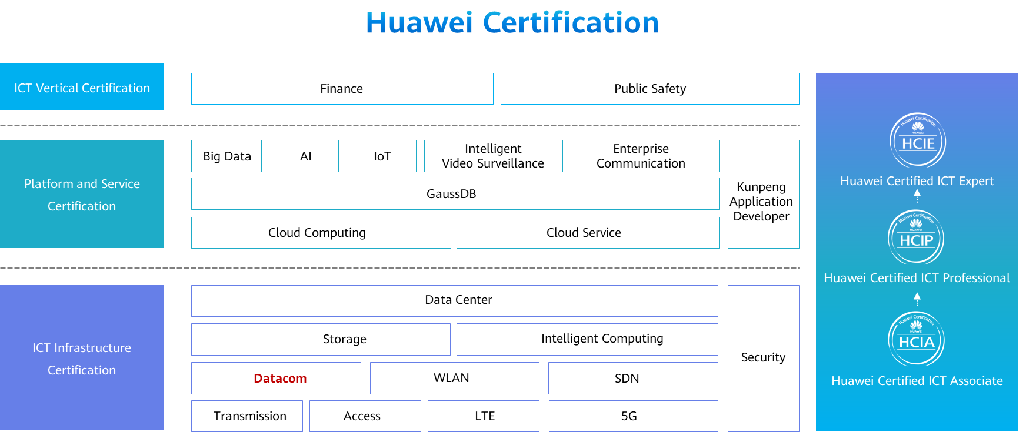

Contents

[1 Huawei VRP Basics 1](#_Toc59714136)

[1.1 Foreword 1](#_Toc59714137)

[1.2 Objectives 1](#_Toc59714138)

[1.3 VRP Overview 2](#_Toc59714139)

[1.3.1 What Is VRP? 2](#_Toc59714140)

[1.3.2 Development of the VRP 3](#_Toc59714141)

[1.3.3 File System 3](#_Toc59714142)

[1.3.4 Storage Media 4](#_Toc59714143)

[1.3.5 Device Initialization Process 4](#_Toc59714144)

[1.3.6 Device Management 4](#_Toc59714145)

[1.3.7 VRP User Interfaces 5](#_Toc59714146)

[1.3.8 VRP User Levels 5](#_Toc59714147)

[1.3.9 Login to the Web System 6](#_Toc59714148)

[1.3.10 CLI - Local Login 7](#_Toc59714149)

[1.3.11 CLI - Remote Login 8](#_Toc59714150)

[1.3.12 CLI 9](#_Toc59714151)

[1.4 Command Line Basics 10](#_Toc59714152)

[1.4.1 Basic Command Structure 10](#_Toc59714153)

[1.4.2 Command Views 11](#_Toc59714154)

[1.4.3 Editing a Command 12](#_Toc59714155)

[1.4.4 Using Command Line Online Help 13](#_Toc59714156)

[1.4.5 Interpreting Command Line Error Messages 14](#_Toc59714157)

[1.4.6 Using Undo Command Lines 14](#_Toc59714158)

[1.4.7 Using Command Line Shortcut Keys 15](#_Toc59714159)

[1.4.8 Common File System Operation Commands 15](#_Toc59714160)

[1.4.9 Basic Configuration Commands 17](#_Toc59714161)

[1.4.10 Case 1: File Query Commands and Directory Operations 20](#_Toc59714162)

[1.4.11 Case 2: File Operations 21](#_Toc59714163)

[1.4.12 Case 3: VRP Basic Configuration Commands 22](#_Toc59714164)

[1.5 Summary 25](#_Toc59714165)

[1.6 Quiz 24](#_Toc59714166)

# Huawei VRP Basics

## Foreword

The Versatile Routing Platform (VRP) is a universal operating system (OS) platform for Huawei datacom products. It is based on IP and adopts a component-based architecture. It provides rich features and functions, including application-based tailorable and extensible functions, greatly improving the running efficiency of the devices that use this OS. To efficiently manage such devices, you must be familiar with VRP and VRP-based configuration.

This course describes the basic concepts, common commands, and command line interface (CLI) of VRP.

## Objectives

On completion of this course, you will be able to:

Understand VRP basics.

Learn how to use CLI.

Master basic CLI commands.

## VRP Overview

### What Is VRP?

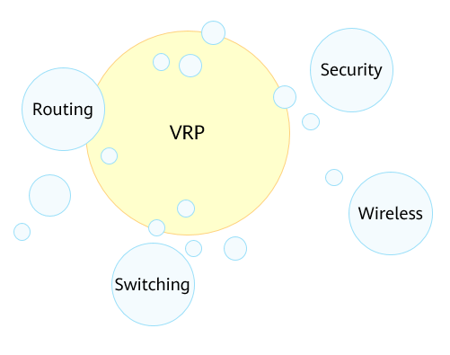

What Is VRP

VRP is a universal OS platform for Huawei datacom products. It serves as the software core engine of Huawei's full series of routers from low-end to core ones, Ethernet switches, service gateways, and so on.

VRP provides the following functions:

* Provides a unified user interface and a unified management interface.
* Implements the functions of the control plane and defines the interface specifications of the forwarding plane.
* Implements communication between the device forwarding plane and VRP control plane.

### Development of the VRP

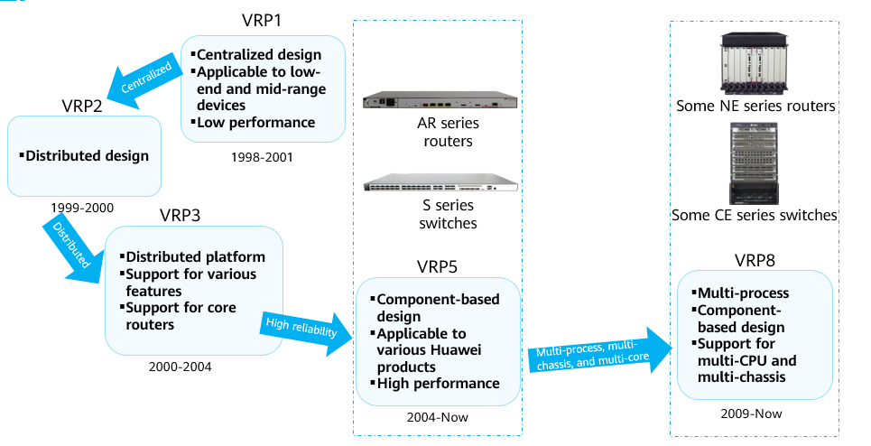

Development of the VRP

### File System

The file system manages files and directories in storage media, allowing users to view, create, rename, and delete directories and copy, move, rename, and delete files.

To manage files on a device, log in to the device through either of the following modes:

* Local login through the console port or Telnet
* Remote login through FTP, TFTP, or SFTP

Mastering the basic operations of the file system is crucial for network engineers to efficiently manage the configuration files and VRP system files of devices.

Common file types:

* System Software: The system software is a must for device startup and operation, providing support, management, and services for a device. The common file name extension is .cc.
* Configuration File: A configuration file stores configuration commands, enabling a device to start with the configurations in the file. A configuration file is a collection of command lines. Current configurations are stored in a configuration file so that the configurations are still effective after the device restarts. Users can view configurations in the configuration file and upload the configuration file to other devices to implement batch configuration. The common file name extensions are .cfg, zip, and .dat.
* Patch File: A patch is a kind of software compatible with the system software. It is used to fix bugs in system software. Patches can also fix system defects and optimize some functions to meet service requirements. The common file name extension is .pat.
* PAF File: A PAF file effectively controls product features and resources. The common file name extension is .bin.

### Storage Media

Storage media include SDRAM, flash memory, NVRAM, SD card, and USB.

* SDRAM is synchronous dynamic random access memory, which is equivalent to a computer's memory. It stores the system running information and parameters.
* The flash memory is nonvolatile and can avoid data loss in case of power-off. It is used to store system software, configuration files, and so on. Patch files and PAF files are uploaded by maintenance personnel and generally stored in the flash memory or SD card.
* NVRAM is nonvolatile random access memory. It is used to store log buffer files. Logs will be written into the flash memory after the timer expires or the buffer is full.
* The SD card can avoid data loss data in case of power-off. The SD card has a large storage capacity and is generally installed on a main control board. It is used to store system files, configuration files, log files, and so on.
* The USB is considered an interface. It is used to connect to a large-capacity storage medium for device upgrade and data transmission.

### Device Initialization Process

After a device is powered on, it runs the BootROM software to initialize the hardware and display hardware parameters. Then, it runs the system software and reads the configuration file from the default storage path to perform initialization.

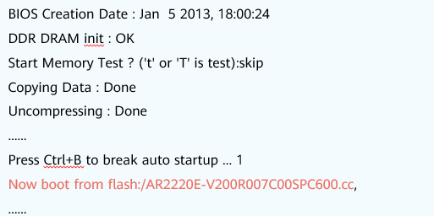

Device Initialization Process

Boot Read-Only Memory (BootROM) is a set of programs added to the ROM chip of a device. BootROM stores the device's most important input and output programs, system settings, startup self-check program, and system automatic startup program.

The startup interface provides the information about the running program of the system, the running VRP version, and the loading path.

### Device Management

There are two commonly used device management modes: CLI and web system.

To use a device management mode, you must first log in to a device through a login mode supported by this device management mode.

Web System

* The web system provides a graphical user interface (GUI) for easy device management and maintenance. This method, however, can be used to manage and maintain only some, not all, device functions.
* The web system supports the HTTP and HTTPS login modes.

CLI

* The CLI requires users to use commands provided by a device to manage and maintain the device. This mode implements refined device management but requires users to be familiar with the commands.
* The CLI supports the console port, Telnet, and SSH login modes.

### VRP User Interfaces

When a user logs in to a device through a CLI-supported mode, the system allocates a user interface to manage and monitor the current session between the user terminal and device.

Such a user interface can be a console user interface or virtual type terminal (VTY) user interface.

Console User Interface

* A console user interface is used to manage and monitor users who log in to a device through the console port.
* The serial port of a user terminal can be directly connected to the console port of a device for local access.

VTY User Interface

* The VTY user interface is used to manage and monitor users who log in to a device by means of VTY.
* After a Telnet or STelnet connection is established between a user terminal and a device, a VTY channel is established to implement remote access to the device.

### VRP User Levels

VRP provides basic permission control functions. It defines the levels of commands that each level of users can execute to restrict the operations of users at different levels.

|  |  |  |  |
| --- | --- | --- | --- |
| User Level | Command Level | Name | Available Command |
| 0 | 0 | Visit level | Network diagnosis commands (such as ping and tracert), commands for accessing external devices from the local device (such as Telnet client commands), and some display commands |
| 1 | 0 and 1 | Monitoring level | System maintenance commands, including display commands |
| 2 | 0, 1, and 2 | Configuration level | Service configuration commands, including routing commands and IP configuration commands, to directly provide users with network services |
| 3-15 | 0, 1, 2, and 3 | Management level | Commands for controlling basic system operations and providing support for services, including the file system, FTP, TFTP download, user management, and command level commands, as well as debugging commands for fault diagnosis |

To limit users' access permissions to a device, the device manages users by level and establishes a mapping between user levels and command levels. After a user logs in to a device, the user can use only commands of the corresponding levels or lower. By default, the user command level ranges from 0 to 3, and the user level ranges from 0 to 15. The mapping between user levels and command levels is shown in the table.

### Login to the Web System

Take the web system for a Huawei AR router as an example. Start a browser on a PC, enter https://192.168.1.1 in the address bar, and press Enter. Then, the web system login page is displayed.

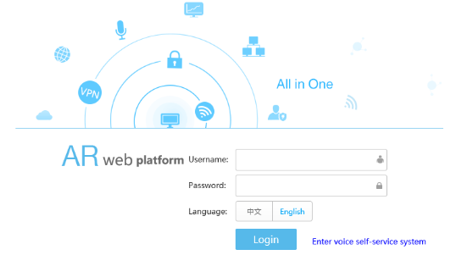

Login to the Web System

Note: The login page, mode, and IP address may vary according to devices. For details, see the product documentation.

### CLI - Local Login

You can log in to a device in local or remote mode. Local login mode:

* Use this mode when you need to configure a device that is powered on for the first time. You can use the console port of the device for a local login.
* The console port is a serial port provided by the main control board of a device.
* To implement the login, directly connect your terminal's serial port to the device's console port, and use PuTTY to log in to the device. You can then configure the device after the login succeeds.

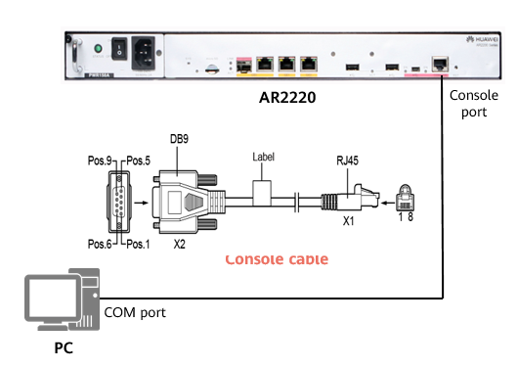

Local Login

Use a console cable to connect the console port of a device with the COM port of a computer. You can then use PuTTY on the computer to log in to the device and perform local commissioning and maintenance. A console port is an RJ45 port that complies with the RS232 serial port standard. At present, the COM ports provided by most desktop computers can be connected to console ports. In most cases, a laptop does not provide a COM port. Therefore, a USB-to-RS232 conversion port is required if you use a laptop.

The console port login function is enabled by default and does not need to be pre-configured.

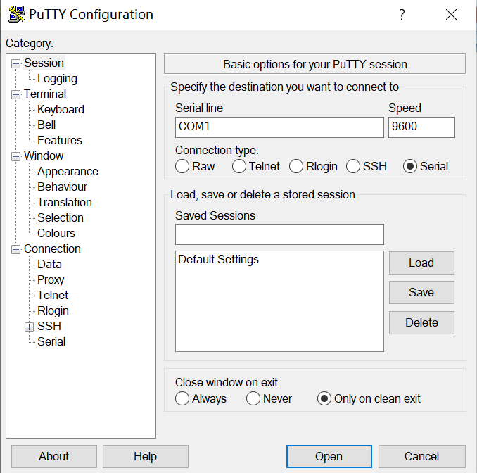

PuTTY Configuration

PuTTY is a connection software for login through Telnet, SSH, serial interfaces, and so on.

In local login, the terminal is connected to the console port of the Huawei device through a serial port. Therefore, set Connection type to Serial. Set Serial line based on the actually used port on the terminal. Set Speed to 9600.

Many terminal simulators can initiate console connections. PuTTY is one of the options for connecting to VRP. If PuTTY is used for access to VRP, you must set port parameters. The figure in the slide shows examples of port parameter settings. If the parameter values were ever changed, you need to restore the default values.

After the settings are complete, click Open. The connection with VRP is then set up.

### CLI - Remote Login

Remote login means that you log in to a device that can function as a remote login server, allowing you to centrally manage and maintain network devices. Remote login methods include Telnet and SSH.

* If you use the SSH login mode, set Connection type to SSH, enter the IP address of the remote login server, and use the default port number 22.
* If you use the Telnet login mode, set Connection type to Telnet, enter the IP address of the remote login server, and use the default port number 23.

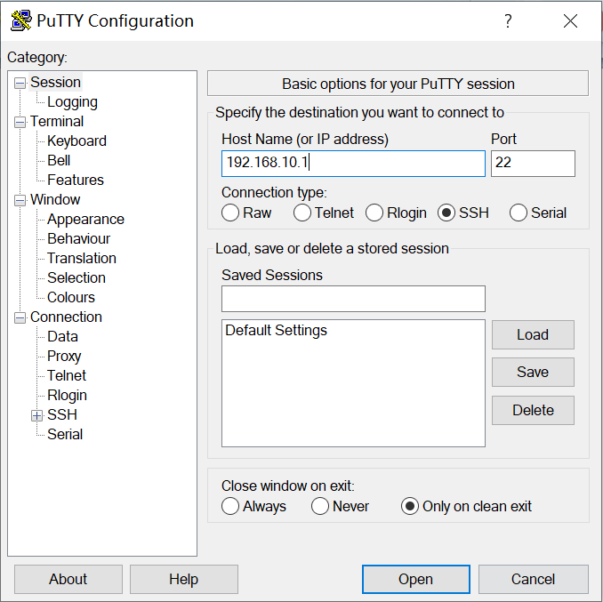

PuTTY Configuration

By default, the SSH login function is disabled on a device. You need to log in to the device through the console port and configure mandatory parameters for SSH login before using the SSH login function.

### CLI

After a login succeeds, the command line interface (CLI) is displayed.

The CLI is a common tool for engineers to interact with network devices. When the command prompt is displayed after a user logs in to a device, it means that the user has entered the CLI successfully.

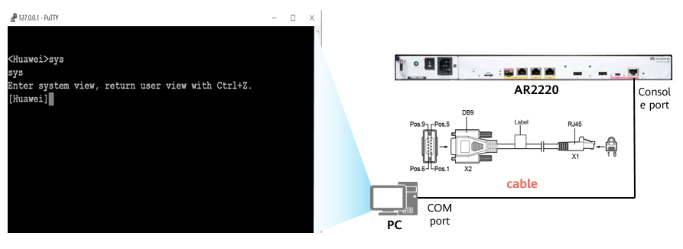

CLI

## Command Line Basics

### Basic Command Structure

CLI commands follow a unified structure. After a command is entered on the CLI, the CLI parses the command and executes it to implement the function of the command, such as query, configuration, or management.

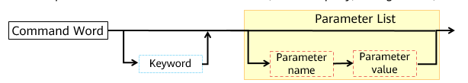

Basic Command Structure

* Command word: specifies the operation to be executed in a command, such as display (device status query) or reboot (device restart).
* Keyword: a special character string that is used to further restrict a command. It is an extension of a command and can also be used to express the command composition logic.
* Parameter list: is composed of parameter names and values to further restrict the command function. It can contain one or more pairs of parameter names and values.

Example 1:

display ip interface GE0/0/0: displays interface information.

Command word: display

Keyword: ip

Parameter name: interface

Parameter value: GE0/0/0

Example 2:

reboot: restarts a device.

Command word: reboot

Each operation command must start with a command word, and the command word is selected from the standard command word list.

Each command must contain a maximum of one command word and can contain multiple keywords and parameters. A parameter must be composed of a parameter name and a parameter value.

The command word, keywords, parameter names, and parameter values in a command are separated by spaces.

### Command Views

A device provides various configuration and query commands. To facilitate the use of these commands, VRP registers the commands in different views according to their functions.

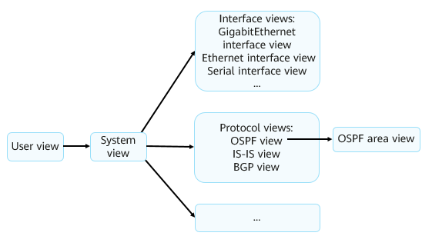

Command Views 1

User view: In this view, you can check the running status and statistics of a device. The user view is the first view displayed after you log in to a device. Only query and tool commands are provided in the user view.

System view: In this view, you can set system parameters and enter the configuration views of other commands. In the user view, only the system view can be accessed. Global configuration commands are provided in the system view. If the system has a lower-level configuration view, the command for entering the lower-level configuration view is provided in the system view.

Other views: In other views, such as the interface view and protocol view, you can set interface parameters and protocol parameters.

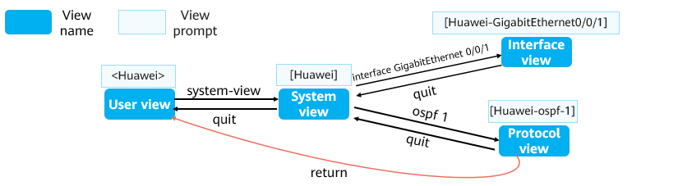

Command Views 2

Command examples:

<Huawei>system-view #This command is used to enter the system view from the user view. The user view is the first view that is displayed after you log in to a device.

[Huawei]interface GigabitEthernet 0/0/1 #This command is used to enter the interface view from the system view.

[Huawei-GigabitEthernet0/0/1]ip address 192.168.1.1 24 #This command is used to set an IP address.

[Huawei-GigabitEthernet0/0/1]quit #This command is used to return to the previous view.

[Huawei]ospf 1 #This command is used to enter the protocol view from the system view.

[Huawei-ospf-1]area 0 #This command is used to enter the OSPF area view from the OSPF view.

[Huawei-ospf-1-area-0.0.0.0]return #This command is used to return to the user view.

After you log in to the system, the user view is displayed first. This view provides only display commands and tool commands, such as ping and telnet. It does not provide any configuration commands.

You can run the system-view command in the user view to enter the system view. The system view provides some simple global configuration commands.

In a complex configuration scenario, for example, multiple parameters need to be configured for an Ethernet interface, you can run the interface GigabitEthernet X command (X indicates the number of the interface) to enter the GE interface view. Configurations performed in this view take effect only on the specified GE interface.

### Editing a Command

The CLI of a device provides basic command editing functions. Common editing functions are as follows:

1. Command editing through function keys

* Backspace: deletes the character before the cursor and moves the cursor to the left. When the cursor reaches the beginning of the command, an alarm is generated.
* Left cursor key ← or Ctrl+B: moves the cursor one character to the left. When the cursor reaches the beginning of the command, an alarm is generated.
* Right cursor key → or Ctrl+F: moves the cursor one character to the right. When the cursor reaches the end of the command, an alarm is generated.

2. Incomplete keyword input

* A device allows the input of incomplete keywords. Specifically, if an entered character string can match a unique keyword, you do not need to enter the remaining characters of the keyword.

<Huawei>d cu

<Huawei>di cu

<Huawei>dis cu

<Huawei>d c

^

Error:Ambiguous command found at '^' position.

<Huawei>dis c

^

Error:Ambiguous command found at '^' position.

* + For example, the display current-configuration command is identified when you enter d cu, di cu, or dis cu. However, the command cannot be identified if you enter d c or dis c because the character string d c or dis c matches more than one command.

Note: "keyword" mentioned in this section means any character string except a parameter value string in a command. The meaning is different from that of "keyword" in the command format.

3. Command editing through the Tab key

* If an entered character string matches a unique keyword, the system automatically supplements the keyword after you press Tab. If the keyword is complete, it remains unchanged even if you press Tab repeatedly.

[Huawei] info- #Press **Tab**.

[Huawei] info-center

* If an entered character string matches more than one keyword, you can press Tab repeatedly. The system will then circularly display the keywords beginning with the entered character string to help you find the desired keyword.

[Huawei] info-center log #Press **Tab**.

[Huawei] info-center logbuffer #Press **Tab** repeatedly to circularly display all matched keywords.

[Huawei] info-center logfile

[Huawei] info-center loghost

* If an entered character string cannot identify any keyword, the entered string remains unchanged after you press **Tab**.

[Huawei] info-center loglog #Enter an incorrect keyword and press **Tab**.

[Huawei] info-center loglog

### Using Command Line Online Help

You can use command line online help to obtain real-time help without memorizing a large number of complex commands.

The online help can be classified into full help and partial help. To obtain the online help, enter a question mark (?) when using a command.

Full Help

* To obtain full help, press ? after a view displayed. The system will then display all commands in the view and their descriptions.

<Huawei> ?

User view commands:

arp-ping ARP-ping

autosave <Group> autosave command group

backup Backup information

cd Change current directory

clear Clear

clock Specify the system clock

Partial Help

* To obtain partial help, press ? after you enter the start character or character string of a command. The system will then display all the commands that start with this character or character string.

<Huawei> d?

debugging <Group> debugging command group

delete Delete a file

dialer Dialer

dir List files on a filesystem

display Display information

The command help information displayed in this slide is for reference only, which varies according to devices.

### Interpreting Command Line Error Messages

If a command passes the syntax check, the system executes it. Otherwise, the system reports an error message.

[Huawei] sysname

^

Error:Incomplete command found at ‘^’ position. #A supplement needs to be made at the position pointed by the arrow.

[Huawei] router if 1.1.1.1

^

Error: Unrecognized command found at ‘^’ position. #An identification failure occurs at the position pointed by the arrow. Check whether the command is correct.

[Huawei] a

^

Error: Ambiguous command found at '^' position. #More than one command matches the keyword at the position pointed by the arrow. In this example, it indicates that there are multiple keywords starting with a.

[Huawei-GigabitEthernet0/0/0]ospf cost 800000 #The parameter value at the position pointed by the arrow is invalid.

^

Error: Wrong parameter found at '^' position.

### Using Undo Command Lines

If a command begins with the keyword undo, it is an undo command. An undo command is generally used to restore a default configuration, disable a function, or delete a configuration. For example:

* Run an undo command to restore a default configuration.

<Huawei> system-view

[Huawei] sysname Server

[Server] undo sysname

[Huawei]

* Run an undo command disable a function.

<Huawei> system-view

[Huawei] ftp server enable

[Huawei] undo ftp server

* Run an undo command to delete a configuration.

[Huawei]interface g0/0/1

[Huawei-GigabitEthernet0/0/1]ip address 192.168.1.1 24

[Huawei-GigabitEthernet0/0/1]undo ip address

### Using Command Line Shortcut Keys

A device provides command shortcut keys to speed up and simplify command input.

Command shortcut keys are classified into user-defined shortcut keys and system shortcut keys.

User-defined Shortcut Keys

* There are four user-defined shortcut keys: Ctrl+G, Ctrl+L, Ctrl+O, and Ctrl+U.
* You can associate a user-defined shortcut key with any command. After you press a shortcut key, the system will automatically run the command associated with the shortcut key.

<Huawei> system-view

[Huawei] hotkey ctrl\_l "display tcp status"

System Shortcut Keys

* CTRL\_A: moves the cursor to the beginning of the current line.
* CTRL\_B: moves the cursor one character to the left.
* CTRL\_C: stops the running of the current command.
* CTRL\_E: moves the cursor to the end of the current line.
* CTRL\_X: deletes all characters on the left of the cursor.
* CTRL\_Y: deletes the character at the cursor and all characters on the right of the cursor.
* CTRL\_Z: returns to the user view.
* CTRL+]: terminates the current connection or switches to another connection.

### Common File System Operation Commands

Check the current directory.

<Huawei>**pwd**

Display information about files in the current directory.

<Huawei>**dir**

Display the content of a text file.

<Huawei>**more**

Change the current working directory.

<Huawei>**acd**

Create a directory.

<Huawei>**makdir**

Delete a directory.

<Huawei>**rmdir**

Copy a file.

<Huawei>**copy**

Move a file.

<Huawei>**move**

Rename a file.

<Huawei>**rename**

Delete a file.

<Huawei>**delete**

Restore a deleted file.

<Huawei>**undelete**

Permanently delete a file in the recycle bin.

<Huawei>**reset recycle-bin**

VRP uses the file system to manages files and directories on a device. To manage files and directories, you often need to run basic commands to query file or directory information. Such commonly used basic commands include **pwd**, **dir [/all]** [ *filename* | *directory* ], and **more** [ **/binary** ] *filename* [ *offset* ] [ **all** ].

* The **pwd** command displays the current working directory.
* The **dir [/all]** [ *filename* | *directory* ] command displays information about files in the current directory.
* The **more [/binary]** *filename* [ *offset* ] **[ all ]** command displays the content of a text file.
* In this example, the **dir** command is run in the user view to display information about files in the flash memory.

Common commands for operating directories include **cd** *directory*, **mkdir** *directory*, and **rmdir** *directory*.

* The **cd** *directory* command changes the current working directory.
* The **mkdir** *directory* command creates a directory. A directory name can contain 1 to 64 characters.
* The **rmdir** *directory* command deletes a directory from the file system. A directory to be deleted must be empty; otherwise, it cannot be deleted using this command.
* The **copy** *source-filename destination-filename* command copies a file. If the target file already exists, the system displays a message indicating that the target file will be replaced. The target file name cannot be the same as the system startup file name. Otherwise, the system displays an error message.
* The **move** *source-filename destination-filename* command moves a file to another directory. The **move** command can be used to move files only within the same storage medium.
* The **rename** *old-name new-name* command renames a directory or file.
* The **delete [/unreserved] [ /force ]** { *filename* | *devicename* } command deletes a file. If the *unreserved* parameter is not specified, the deleted file is moved to the recycle bin. A file in the recycle bin can be restored using the **undelete** command. However, if the **/unreserved** parameter is specified, the file is permanently deleted and cannot be restored any more. If the **/force** parameter is not specified in the **delete** command, the system displays a message asking you whether to delete the file. However, if the **/force** parameter is specified, the system does not display the message. *filename* specifies the name of the file to be deleted, and *devicename* specifies the name of the storage medium.
* The **reset recycle-bin** [ *filename* | *devicename* ] command permanently deletes all or a specified file in the recycle bin. *filename* specifies the name of the file to be permanently deleted, and *devicename* specifies the name of the storage medium.

### Basic Configuration Commands

Configure a system name.

[Huawei] **sysname** *name*

Configure a system clock.

<Huawei> clock timezone *time-zone-name* { add | minus } *offset*

This command configures a local time zone.

<Huawei> **clock datetime** [ **utc** ] *HH:MM:SS YYYY-MM-DD*

This command configures the current or UTC date and time.

<Huawei> clock daylight-saving-time

This command configures the daylight saving time.

Configure a command level.

[Huawei] **command-privilege level** *level* **view** *view-name command-key*

This command configures a level for commands in a specified view. Command levels are classified into visit, monitoring, configuration, and management, which are identified by the numbers 0, 1, 2, and 3, respectively.

Configure the password-based login mode.

[Huawei]user-interface vty 0 4

[Huawei-ui-vty0-4]set authentication password cipher *information*

This **user-interface vty** command displays the virtual type terminal (VTY) user interface view, and the **set authentication password** command configures the password authentication mode. The system supports the console user interface and VTY user interface. The console user interface is used for local login, and the VTY user interface is used for remote login. By default, a device supports a maximum of 15 concurrent VTY-based user accesses.

Configure user interface parameters.

[Huawei] **idle-timeout** *minutes [ seconds ]*

This command sets a timeout period to disconnect from the user interface. If no command is entered within the specified period, the system tears down the current connection. The default timeout period is 10 minutes.

Configure an IP address for an interface.

[Huawei]**interface** *interface-number*

[Huawei-*interface-number*]**ip address** *ip address*

This command configures an IP address for a physical or logical interface on a device.

Display currently effective configurations.

<Huawei>display current-configuration

Save a configuration file.

<Huawei>**save**

Check saved configurations.

<Huawei>display saved-configuration

Clear saved configurations.

<Huawei>reset saved-configuration

Check system startup configuration parameters.

<Huawei> display startup

This command displays the system software for the current and next startup, backup system software, configuration file, license file, and patch file, as well as voice file.

Configure the configuration file for next startup.

<Huawei>startup saved-configuration *configuration-file*

During a device upgrade, you can run this command to configure the device to load the specified configuration file for the next startup.

Restart a device.

<Huawei>**reboot**

Generally, more than one device is deployed on a network, and the administrator needs to manage all devices in a unified manner. The first task of device commissioning is to set a system name. A system name uniquely identifies a device. The default system name of an AR series router is Huawei, and that of an S series switch is HUAWEI. A system name takes effect immediately after being set.

To ensure successful coordination with other devices, you need to correctly set the system clock. System clock = Coordinated Universal Time (UTC) ± Time difference between the UTC and the time of the local time zone. Generally, a device has default UTC and time difference settings.

* You can run the **clock datetime** command to set the system clock of the device. The date and time format is HH:MM:SS YYYY-MM-DD. If this command is run, the UTC is the system time minus the time difference.
* You can also change the UTC and the system time zone to change the system clock.
  + The **clock datetime utc** *HH:MM:SS YYYY-MM-DD* changes the UTC.
  + The **clock timezone** *time-zone-name* { **add** | **minus** } *offset* command configures the local time zone. The UTC is the local time plus or minus the offset.
* If a region adopts the daylight saving time, the system time is adjusted according to the user setting at the moment when the daylight saving time starts. VRP supports the daylight saving time function.

Each type of user interface has a corresponding user interface view. A user interface view is a command line view provided by the system for you to configure and manage all physical and logical interfaces working in asynchronous interaction mode, implementing unified management of different user interfaces. Before accessing a device, you need to set user interface parameters. The system supports console and VTY user interfaces. The console port is a serial port provided by the main control board of a device. A VTY is a virtual line port. A VTY connection is set up after a Telnet or SSH connection is established between a user terminal and a device, allowing the user to access the device in VTY mode. Generally, a maximum of 15 users can log in to a device through VTY at the same time. You can run the **user-interface maximum-vty** *number* command to set the maximum number of users that can concurrently access a device in VTY mode. If the maximum number of login users is set to 0, no user can log in to the device through Telnet or SSH. The **display user-interface** command displays information about a user interface.

The maximum number of VTY interfaces may vary according to the device type and used VRP version.

To run the IP service on an interface, you must configure an IP address for the interface. Generally, an interface requires only one IP address. For the same interface, a newly configured primary IP address replaces the original primary IP address.

You can run the **ip address** { *mask* | *mask-length* } command to configure an IP address for an interface. In this command, *mask* indicates a 32-bit subnet mask, for example, 255.255.255.0; *mask-length* indicates a mask length, for example, 24. Specify either of them when configuring an IP address.

A loopback interface is a logical interface that can be used to simulate a network or an IP host. The loopback interface is stable and reliable, and can also be used as the management interface if multiple protocols are deployed.

When configuring an IP address for a physical interface, check the physical status of the interface. By default, interfaces are up on Huawei routers and switches. If an interface is manually disabled, run the **undo shutdown** command to enable the interface after configuring an IP address for it.

The **reset saved-configuration** command deletes the configurations saved in a configuration file or the configuration file. After this command is run, if you do not run the **startup saved-configuration** command to specify the configuration file for the next startup or the **save** command to save current configurations, the device uses the default parameter settings during system initialization when it restarts.

The **display startup** command displays the system software for the current and next startup, backup system software, configuration file, license file, and patch file, as well as voice file.

The **startup saved-configuration** *configuration-file* command configures the configuration file for the next startup. The *configuration-file* parameter specifies the name of the configuration file for the next startup.

The **reboot** command restarts a device. Before the device reboots, you are prompted to save configurations.

### Case 1: File Query Commands and Directory Operations

Requirement description:

* Check information about files and directories in the current directory of a router named RTA.
* Create a directory named **test**, and then delete the directory.

<Huawei>**pwd**

flash:

<Huawei>**dir**

Directory of flash:/

Idx Attr Size(Byte) Date Time(LMT) FileName

0 drw- - Dec 27 2019 02:54:09 dhcp

1 -rw- 121,802 May 26 2014 09:20:58 portalpage.zip

2 -rw- 2,263 Dec 27 2019 02:53:59 statemach.efs

3 -rw- 828,482 May 26 2014 09:20:58 sslvpn.zip

1,090,732 KB total (784,464 KB free)

<Huawei>**mkdir test**

<Huawei>**dir**

Directory of flash:/

Idx Attr Size(Byte) Date Time(LMT) FileName

0 drw- - Dec 27 2019 02:54:39 test

1 drw- - Dec 27 2019 02:54:09 dhcp

2 -rw- 121,802 May 26 2014 09:20:58 portalpage.zip

3 -rw- 2,263 Dec 27 2019 02:53:59 statemach.efs

4 -rw- 828,482 May 26 2014 09:20:58 sslvpn.zip

1,090,732 KB total (784,460 KB free)

<Huawei>**rmdir test**

### Case 2: File Operations

Requirement description:

* Rename the **huawei.txt** file **save.zip**.
* Make a copy for the **save.zip** file and name the copy **file.txt**.
* Move the **file.txt** file to the **dhcp** directory.
* Delete the **file.txt** file.
* Restore the deleted file **file.txt**.

<Huawei>rename huawei.txt save.zip

<Huawei>dir

Directory of flash:/

Idx Attr Size(Byte) Date Time(LMT) FileName

0 drw- - Mar 04 2020 04:39:52 dhcp

1 -rw- 121,802 May 26 2014 09:20:58 portalpage.zip

2 -rw- 828,482 Mar 04 2020 04:51:45 save.zip

3 -rw- 2,263 Mar 04 2020 04:39:45 statemach.efs

4 -rw- 828,482 May 26 2014 09:20:58 sslvpn.zip

1,090,732 KB total (784,464 KB free)

<Huawei>copy save.zip file.txt

<Huawei>dir

Directory of flash:/

Idx Attr Size(Byte) Date Time(LMT) FileName

0 drw- - Mar 04 2020 04:39:52 dhcp

1 -rw- 121,802 May 26 2014 09:20:58 portalpage.zip

2 -rw- 828,482 Mar 04 2020 04:51:45 save.zip

3 -rw- 2,263 Mar 04 2020 04:39:45 statemach.efs

4 -rw- 828,482 May 26 2014 09:20:58 sslvpn.zip

5 -rw- 828,482 Mar 04 2020 04:56:05 file.txt

1,090,732 KB total (784,340 KB free)

<Huawei>move file.txt flash:/dhcp/

<Huawei>cd dhcp

<Huawei>dir

Directory of flash:/dhcp/

Idx Attr Size(Byte) Date Time(LMT) FileName

0 -rw- 98 Dec 27 2019 02:54:09 dhcp-duid.txt

1 -rw- 121,802 Dec 27 2019 03:13:50 file.txt

1,090,732 KB total (784,344 KB free)

<Huawei>delete file.txt

<Huawei>dir

Directory of flash:/dhcp/

Idx Attr Size(Byte) Date Time(LMT) FileName

0 -rw- 98 Dec 27 2019 02:54:09 dhcp-duid.txt

1,090,732 KB total (784,340 KB free)

<Huawei>undelete file.txt

<Huawei>dir

Directory of flash:/dhcp/

Idx Attr Size(Byte) Date Time(LMT) FileName

0 -rw- 98 Dec 27 2019 02:54:09 dhcp-duid.txt

1 -rw- 121,802 Dec 27 2019 03:13:50 file.txt

1,090,732 KB total (784,340 KB free)

### Case 3: VRP Basic Configuration Commands

As shown in the figure, an engineer needs to configure a router. The requirements are as follows:

* Connect the router and PC. Assign the IP addresses shown in the figure to the router and PC.
* Allow other employees of the company to use the password **huawei123** to remotely log in to the router through the PC. Allow them to view configurations but disable them from modifying configurations.
* Save current configurations and name the configuration file **huawei.zip**. Configure this file as the configuration file for the next startup.

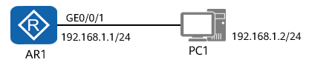

VRP Basic Configuration

Configuration Procedure:

Configure an interface IP address.

<Huawei>system-view

[Huawei]sysname AR1

[AR1]interface GigabitEthernet 0/0/1

[AR1-GigabitEthernet0/0/1]ip address 192.168.1.1 24

[AR1-GigabitEthernet0/0/1]quit

Configuring a user level and a user authentication mode.

[AR1]user-interface vty 0 4

[Huawei-ui-vty0-4]authentication-mode password

Please configure the login password (maximum length 16):huawei123

[AR1-ui-vty0-4]user privilege level 1

[AR1-ui-vty0-4]quit

* The password configuration command may vary according to devices. For details, see the product documentation.
* For some devices, after the **authentication-mode password** command is entered, the password setting page will be displayed automatically. You can then enter the password at the page that is displayed. For some devices, you need to run the **set authentication-mode password** *password* command to set a password.

Specify the configuration file for next startup.

<HUAWEI>save huawei.zip

Are you sure to save the configuration to huawei.zip? (y/n)[n]:y

It will take several minutes to save configuration file, please wait.........

Configuration file had been saved successfully

Note: The configuration file will take effect after being activated

<HUAWEI>startup saved-configuration huawei.zip

* By default, configurations are saved in the vrpcfg.cfg file. You can also create a file for saving the configurations. VRPv5 and VRPv8 have the same command that is used to specify the configuration file for the next startup, but different directories for saving the file.
* To save configurations, run the **save** command. By default, configurations are saved in the **vrpcfg.cfg** file. You can also create a file for saving the configurations. In VRPv5, the configuration file is stored in the flash**:** directory by default.

Checking Configurations

<AR1>display startup

MainBoard:

Startup system software: null

Next startup system software: null

Backup system software for next startup: null

Startup saved-configuration file: flash:/vrpcfg.zip

Next startup saved-configuration file: flash:/huawei.zip

Startup license file: null

Next startup license file: null

Startup patch package: null

Next startup patch package: null

Startup voice-files: null

Next startup voice-files: null

* The **display startup** command displays the system software for the current and next startup, backup system software, configuration file, license file, and patch file, as well as voice file.
* **Startup system software** indicates the VRP file used for the current startup.
* **Next startup system software** indicates the VRP file to be used for the next startup.
* **Startup saved-configuration file** indicates the configuration file used for the current system startup.
* **Next startup saved-configuration file** indicates the configuration file to be used for the next startup.
* When a device starts, it loads the configuration file from the storage medium and initializes the configuration file. If no configuration file exists in the storage medium, the device uses the default parameter settings for initialization.
* The **startup saved-configuration** [ *configuration-file* ] command sets the configuration file for the next startup, where the *configuration-file* parameter specifies the name of the configuration file.

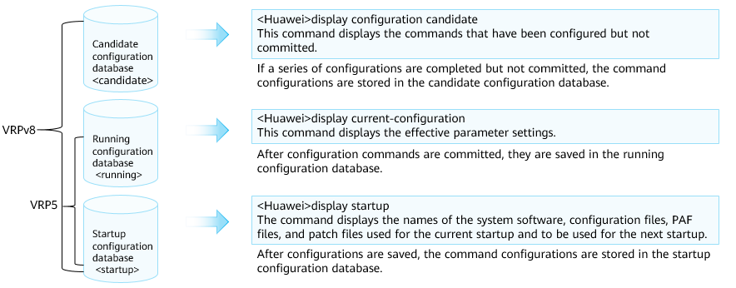

More Information

VRPv5 has the running and startup configuration databases but does not have the candidate configuration database. Therefore, a command configuration takes effect immediately after the command is executed, without being committed. However, in VRPv8, the configuration command takes effect only after the command committed.

## Quiz

1. (Single) In which view is the *sysname Huawei* command used to set the device name to Huawei? ( )
2. User view
3. System view
4. interface view
5. protocol view
6. (Single) Which of the following statements about storage devices is false? ( )
7. Flash is a non-volatile memory. Data will not be lost after a power failure.
8. NVRAM non-volatile random access memory for configuration files
9. The SD card can store system files, configuration files, and logs.
10. SDRAM is equivalent to the memory of a computer.
11. (Multiple) Which of the following views cannot be used by the save command? ( )
12. User view
13. System view
14. Interface view
15. Protocol view
16. (True or False) Huawei VRP does not have a file system. Therefore, you cannot perform operations on files. You must use external tools to perform operations on files. ( )
17. True
18. False
19. (True or False)When using the console port to manage the device, only one person can perform this operation at the same time. When using the VTY port, multiple persons can perform this operation at the same time. ( )
20. True
21. False
22. What is the VRP version currently used by Huawei datacom devices?
23. What is the maximum number of users that are allowed to log in to a Huawei device through the console port concurrently?
24. How do I specify the configuration file for next startup if a device has multiple configuration files?

## Summary

VRP is a Huawei proprietary network OS that can run on various hardware platforms. VRP has unified network, user, and management interfaces. To efficiently manage Huawei devices, you need to be familiar with VRP commands and configurations.

You also need to understand some common commands and shortcut keys and learn how to use them.

After learning this course, you need to know basic VRP concepts, functions of common commands, and CLI.